**Udacity - Flying Cars and Autonomous Flight Engineer Nanodegree**

Estimation Project Write Up

Yu Hin Hau

12/17/2021

In this project, I implemented an Extended Kalman Filter to estimate the drone’s state variable. The EKF work by estimating the state via an internal physics model. It is then updated by measurements from the GPS and magnetometer whenever the readings come in one at a time. The drone’s attitude is determined by an non-linear complementary filter.

**1) Determine Standard Deviation of the Measurement Noise Data**

I calculated the standard deviation by starting a jupyter notebook, loading the data into Pandas and performed an analysis on the GPS and accelerometer X data.

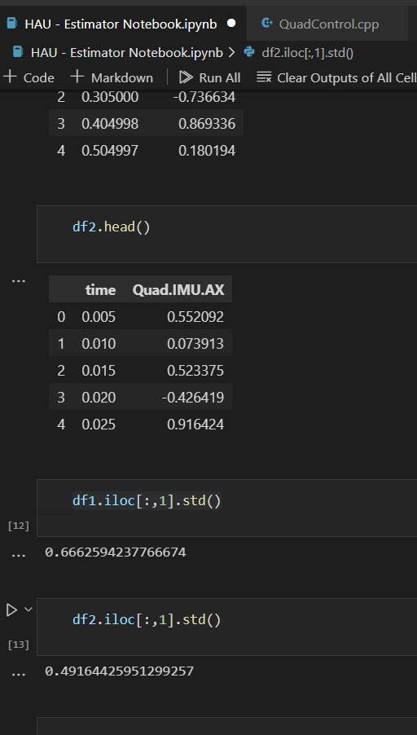

**2) Implement a better attitude estimation scheme**

To improve attitude estimation, I implemented a non-linear complemetary filter via quanterion.

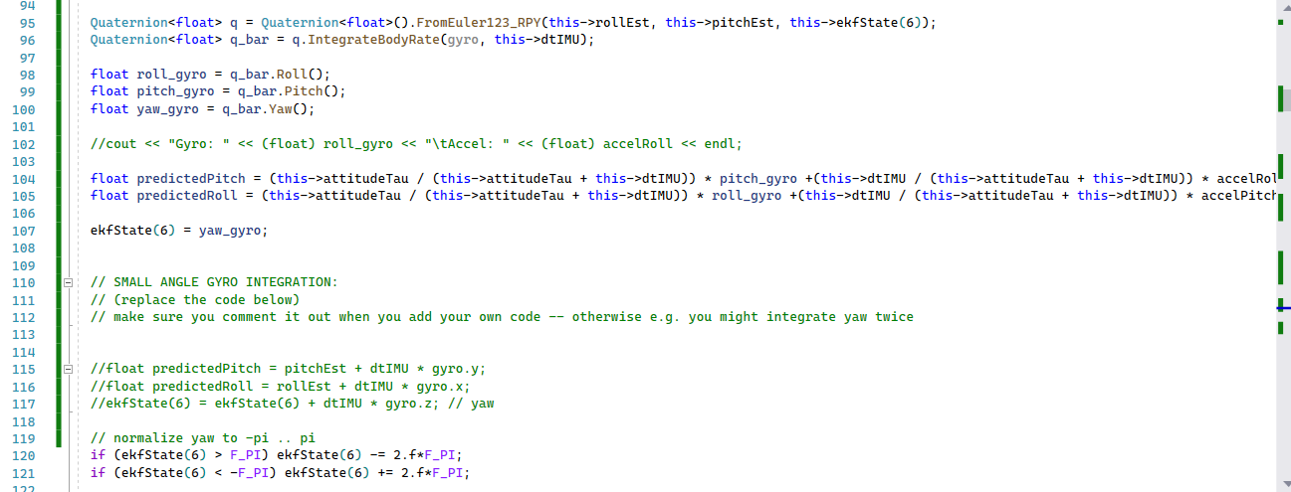

**3) Implement StatePredict, RbgPrime matrix and Covariance State Update**

I implemented the equation as noted in the technical paper included in the course.

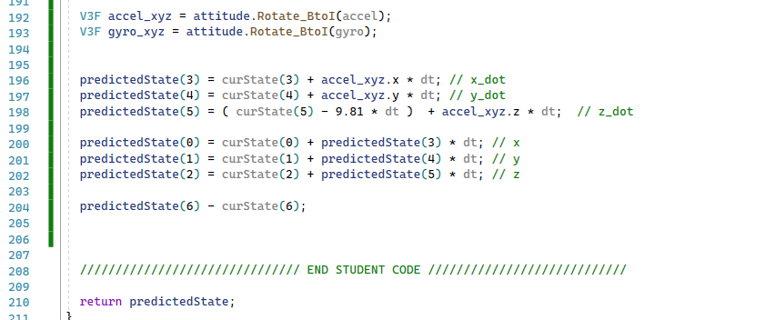

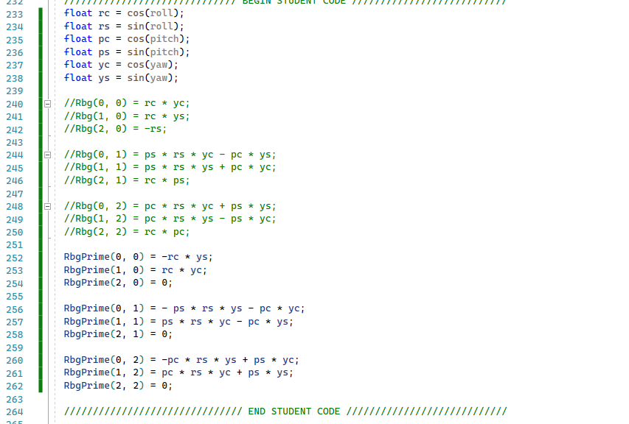

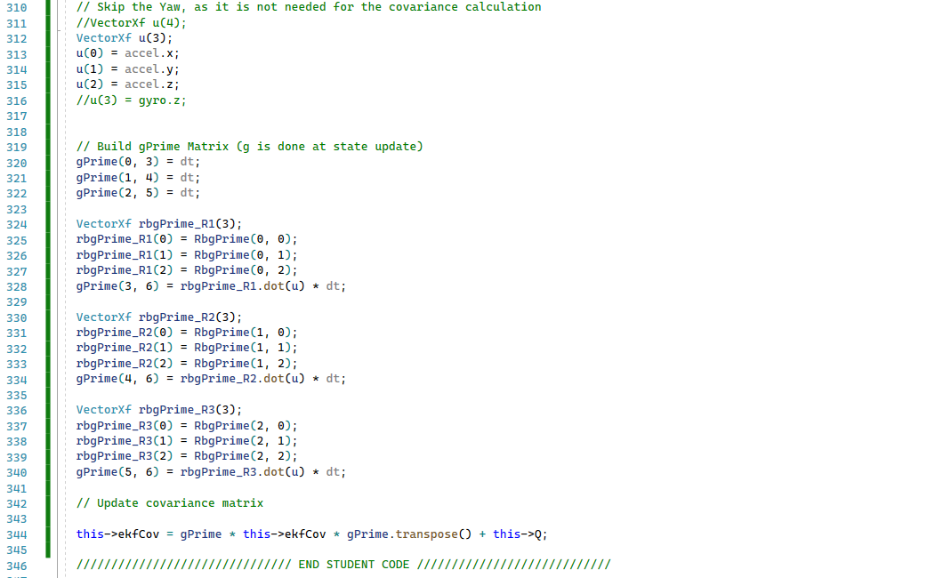

**3) Implement Magnetometer**

I implemented the magnetometer and use it to update yaw via the EKF.

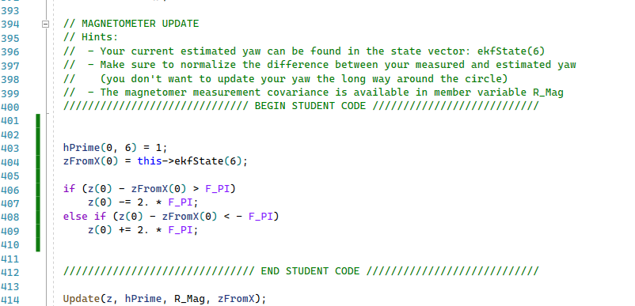

**4) Implement GPS**

I used a for loop to update all the states from the GPS to enhance the EKF’s internal model.

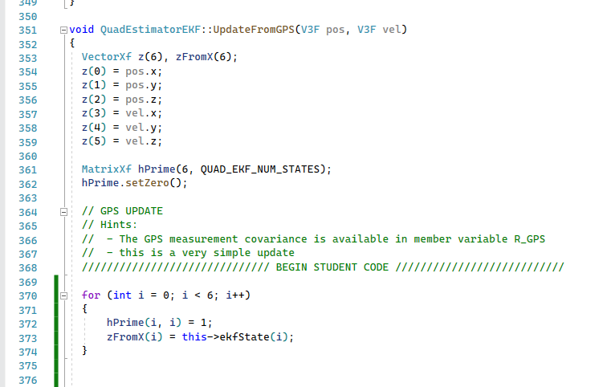

**5 + 6) Meet all critera in Simulator and Retune PID Controller**

I retuned my PID controller, decrease translational gain in XY direction and increase Z direction responsiviness. And it finally is able to follow the path without crashing.

